**Sales Data**

1. Database Creation

-- Create Database

CREATE DATABASE sales_data;

USE sales_data;

-- Create Table

CREATE TABLE sales_sample (

Product_Id INT,

Region VARCHAR(50),

Date DATE,

Sales_Amount DECIMAL(10,2),

INDEX idx_product (Product_Id),

INDEX idx_region (Region),

INDEX idx_date (Date)

);

-- Insert Sample Data

INSERT INTO sales_sample (Product_Id, Region, Date, Sales_Amount) VALUES

(1001, 'East', '2024-01-15', 5000.00),

(1002, 'West', '2024-01-15', 6500.00),

(1001, 'North', '2024-01-20', 4500.00),

(1003, 'South', '2024-01-20', 7500.00),

(1002, 'East', '2024-02-01', 5500.00),

(1004, 'West', '2024-02-01', 8500.00),

(1003, 'North', '2024-02-05', 6000.00),

(1001, 'South', '2024-02-05', 7000.00),

(1004, 'East', '2024-02-10', 9000.00),

(1002, 'West', '2024-02-10', 8000.00);

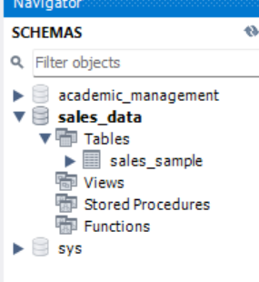

1. OLAP Functions
2. Drill Down-Analyze sales data at a more detailed level. Write a query to perform drill down from region to product level to understand sales performance.

-- Level 1: Total Sales by Region

SELECT

Region,

SUM(Sales_Amount) as Total_Sales

FROM

sales_sample

GROUP BY

Region

ORDER BY

Total_Sales DESC;

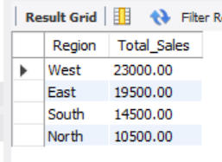

- Level 2: Region and Product Level

SELECT

Region,

Product_Id,

SUM(Sales_Amount) as Total_Sales

FROM

sales_sample

GROUP BY

Region, Product_Id

ORDER BY

Region, Total_Sales DESC;

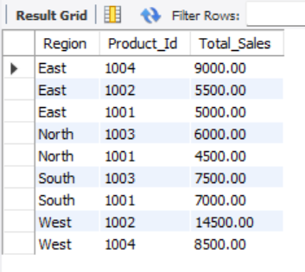

-- Level 3: Region, Product, and Monthly Level

SELECT

Region,

Product_Id,

DATE_FORMAT(Date, '%Y-%m') as Month,

SUM(Sales_Amount) as Total_Sales

FROM

sales_sample

GROUP BY

Region, Product_Id, DATE_FORMAT(Date, '%Y-%m')

ORDER BY

Region, Product_Id, Month;

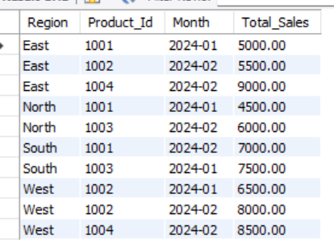

-- Level 4: Most Detailed Level (All Dimensions)

SELECT

Region,

Product_Id,

Date,

Sales_Amount

FROM

sales_sample

ORDER BY

Region, Product_Id, Date;

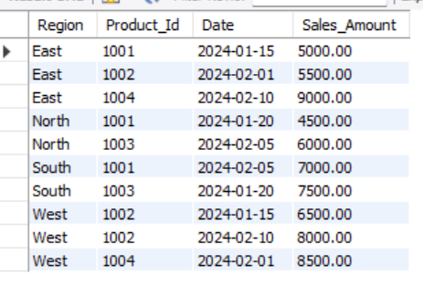

1. Rollup- To summarize sales data at different levels of granularity. Write a query to perform roll up from product to region level to view total sales by region.

-- 1. Basic ROLLUP - Region and Product Level

SELECT

Region,

Product_Id,

SUM(Sales_Amount) as Total_Sales,

COUNT(*) as Number_of_Transactions

FROM

sales_sample

GROUP BY

Region, Product_Id

WITH ROLLUP

ORDER BY

Region, Product_Id;

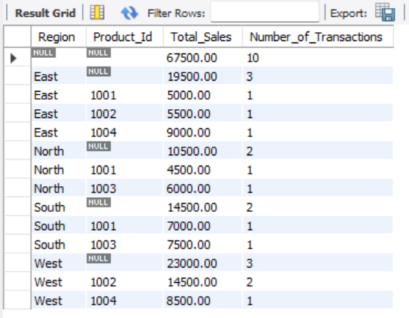

-- 2. ROLLUP with Time Dimension

SELECT

Region,

DATE_FORMAT(Date, '%Y-%m') as Month,

SUM(Sales_Amount) as Total_Sales

FROM

sales_sample

GROUP BY

Region, DATE_FORMAT(Date, '%Y-%m')

WITH ROLLUP

ORDER BY

Region, Month;

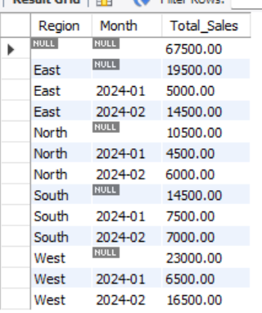

-- 4. ROLLUP with Percentage Contribution

WITH SalesRollup AS (

SELECT

Region,

Product_Id,

SUM(Sales_Amount) as Total_Sales

FROM

sales_sample

GROUP BY

Region, Product_Id

WITH ROLLUP

)

SELECT

IFNULL(Region, 'Grand Total') as Region,

IFNULL(Product_Id, 'Region Total') as Product_Id,

Total_Sales,

ROUND(

(Total_Sales / SUM(Total_Sales) OVER()) * 100,

2

) as Percentage_of_Total

FROM

SalesRollup

ORDER BY

Region, Product_Id;

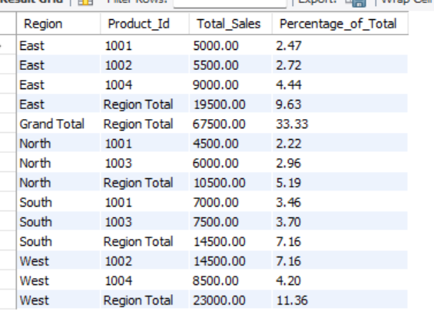

-- 6. Region-wise Product Performance with ROLLUP

SELECT

IFNULL(Region, 'Grand Total') as Region,

IFNULL(Product_Id, 'Region Total') as Product_Id,

SUM(Sales_Amount) as Total_Sales,

COUNT(*) as Number_of_Sales,

ROUND(AVG(Sales_Amount), 2) as Avg_Sale_Amount,

MIN(Sales_Amount) as Min_Sale,

MAX(Sales_Amount) as Max_Sale

FROM

sales_sample

GROUP BY

Region, Product_Id

WITH ROLLUP

HAVING

Total_Sales > 5000

ORDER BY

Region, Product_Id;

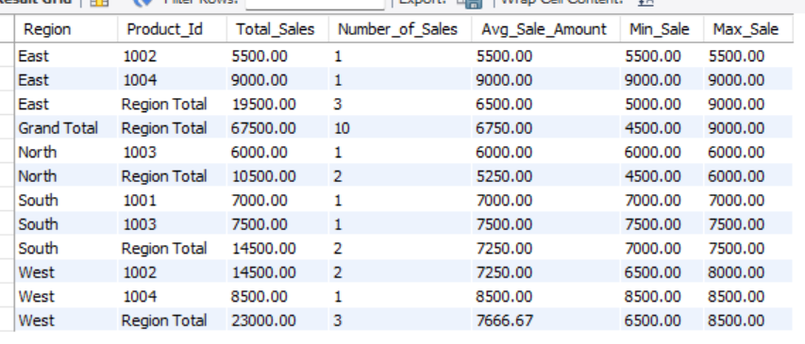

1. Cube - To analyze sales data from multiple dimensions simultaneously. Write a query to Explore sales data from different perspectives, such as product, region, and date.

SELECT

COALESCE(Region, 'All Regions') as Region,

COALESCE(Product_Id, 'All Products') as Product_Id,

SUM(Sales_Amount) as Total_Sales,

COUNT(*) as Number_of_Sales

FROM

sales_sample

GROUP BY

Region, Product_Id WITH ROLLUP;

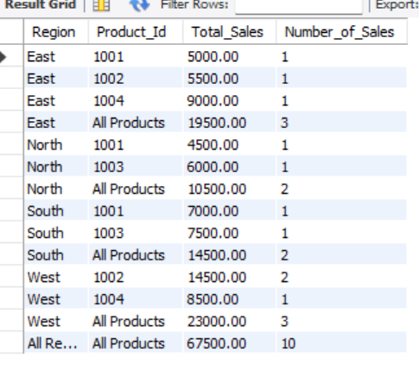

SELECT

COALESCE(Product_Id, 'All Products') as Product_Id,

COUNT(*) as Number_of_Sales,

SUM(Sales_Amount) as Total_Sales,

AVG(Sales_Amount) as Average_Sale

FROM

sales_sample

GROUP BY

Product_Id WITH ROLLUP;

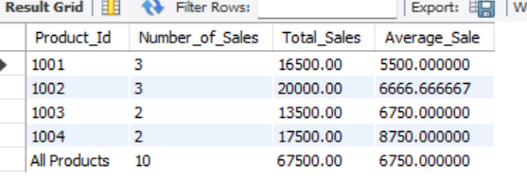

1. Slice- To extract a subset of data based on specific criteria. Write a query to slice the data to view sales for a particular region or date range.

SELECT

Product_Id,

Date,

Sales_Amount,

Region

FROM

sales_sample

WHERE

Region = 'East'

ORDER BY

Date;

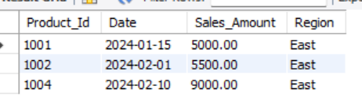

SELECT

Product_Id,

COUNT(*) as Number_of_Sales,

SUM(Sales_Amount) as Total_Sales,

AVG(Sales_Amount) as Average_Sale,

MIN(Sales_Amount) as Minimum_Sale,

MAX(Sales_Amount) as Maximum_Sale

FROM

sales_sample

WHERE

Region = 'East'

GROUP BY

Product_Id

ORDER BY

Total_Sales DESC;

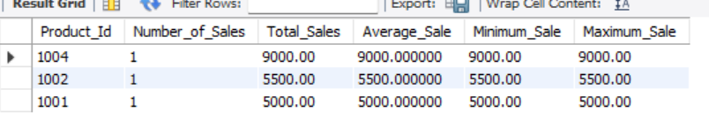

1. Dice - To extract data based on multiple criteria. Write a query to view sales for specific combinations of product, region, and date.

-- 1. Basic Dice: View sales for specific product and region

SELECT

Date,

Product_Id,

Region,

Sales_Amount

FROM

sales_sample

WHERE

Product_Id IN (1001, 1002)

AND Region IN ('East', 'West')

ORDER BY

Date;

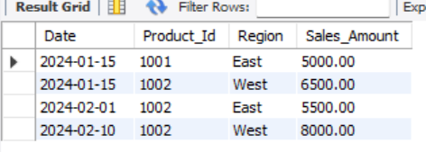

-- 4. Dice with Daily Analysis

SELECT

Date,

Region,

COUNT(*) as Sales_Count,

SUM(Sales_Amount) as Daily_Sales

FROM

sales_sample

WHERE

Product_Id IN (1001, 1002)

AND Region IN ('East', 'West')

AND MONTH(Date) = 1

GROUP BY

Date, Region

ORDER BY

Date, Region;

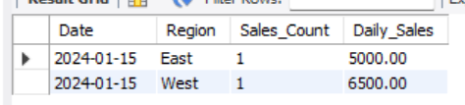

-- 6. Dice with Monthly Comparison

SELECT

DATE_FORMAT(Date, '%Y-%m') as Month,

Region,

Product_Id,

SUM(Sales_Amount) as Monthly_Sales

FROM

sales_sample

WHERE

Product_Id IN (1001, 1002)

AND Region IN ('East', 'West')

GROUP BY

DATE_FORMAT(Date, '%Y-%m'), Region, Product_Id

ORDER BY

Month, Region, Product_Id;

